**Name: Rohan Babulnath Kamble**

**PRN: 2020420004**

**Class: S.Y.B.Sc Computer Science**

**Subject Code: USCS402**

**Subject Name: Advanced Java Practical Journal**

**Practical 1**

**Aim: Design suitable database for Library Management System.**

**Step 1 : Create Database**

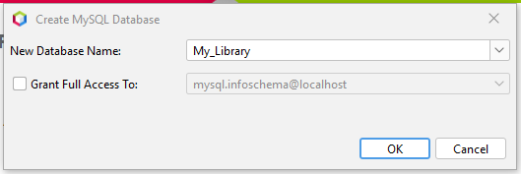

**Step 2 : Create Table**

**Add Columns(B_ID , B_NAME , B_COST)**

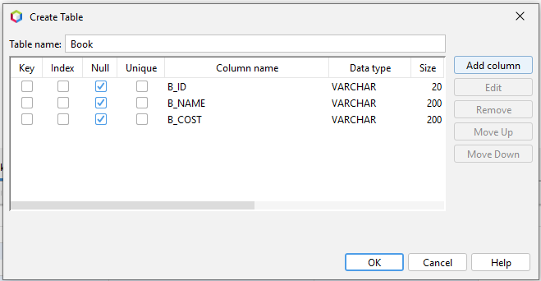

**Step 3: Insert Records**

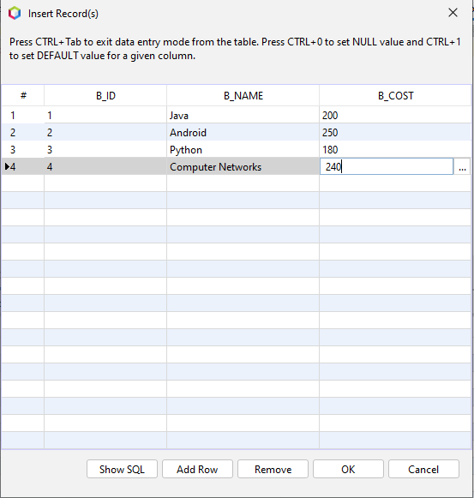

**Final Output:**

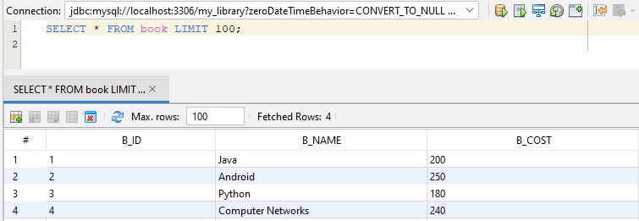

**Practical 2**

**Aim: Write a Java application to demonstrate servlet life cycle.**

**HTML Code:**

<!DOCTYPE html>

<!--

To change this license header, choose License Headers in Project Properties.

To change this template file, choose Tools | Templates

and open the template in the editor.

-->

<html>

<head>

<title>TODO supply a title</title>

<meta charset="UTF-8">

<meta name="viewport" content="width=device-width, initial-scale=1.0">

</head>

<body>

<form action="clac" method="post">

Enter First Number :

<input type="text" name="txtN1" ><br>

Enter Second Number :

<input type="text" name="txtN2" ><br>

Select an Operation

<input type="radio" name="opr" value="+">ADDTION

<input type="radio" name="opr" value="-">SUBSTRACTION

<input type="radio" name="opr" value="*">MULTIPLY

<input type="radio" name="opr" value="/">DIVIDE <br>

<input type="reset">

<input type="submit" value="Calculate" >

</form>

</body>

</html>

**Program Code:**

(Servlet Calculator Program)

/*

* To change this license header, choose License Headers in Project Properties.

* To change this template file, choose Tools | Templates

* and open the template in the editor.

*/

package test;

import java.io.IOException;

import java.io.PrintWriter;

import javax.servlet.ServletException;

import javax.servlet.http.HttpServlet;

import javax.servlet.http.HttpServletRequest;

import javax.servlet.http.HttpServletResponse;

/**

*

* @author user

*/

public class clac extends HttpServlet {

/**

* Processes requests for both HTTP <code>GET</code> and <code>POST</code>

* methods.

*

* @param request servlet request

* @param response servlet response

* @throws ServletException if a servlet-specific error occurs

* @throws IOException if an I/O error occurs

*/

@Override

protected void doPost(HttpServletRequest request, HttpServletResponse response)

throws ServletException, IOException {

double n1 = Double.parseDouble(request.getParameter("txtN1"));

double n2 = Double.parseDouble(request.getParameter("txtN2"));

String opr=request.getParameter("opr");

response.setContentType("text/html;charset=UTF-8");

try (PrintWriter out = response.getWriter()) {

double result =0;

if(opr.equals("+")) result=n1+n2;

if(opr.equals("-")) result=n1-n2;

if(opr.equals("*")) result=n1*n2;

if(opr.equals("/")) result=n1/n2;

out.println("<h1> Result = "+result);

/* TODO output your page here. You may use following sample code. */

out.println("<!DOCTYPE html>");

out.println("<html>");

out.println("<head>");

out.println("<title>Servlet clac</title>");

out.println("</head>");

out.println("<body>");

out.println("<h1>Servlet clac at " + request.getContextPath() + "</h1>");

out.println("</body>");

out.println("</html>");

}

}

}

**Output:**

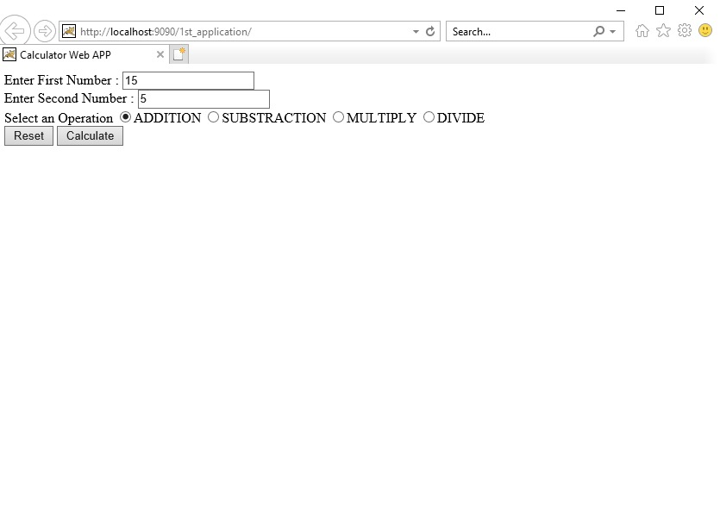

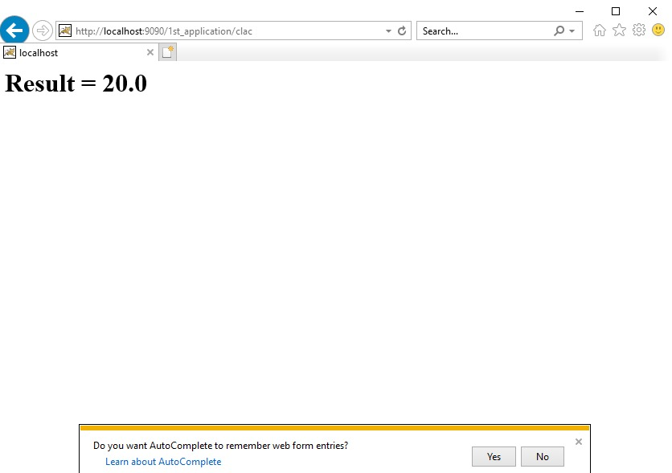

**Practical 3**

**Aim: Design database for student administration. Develop servlet(s) to perform CRUD operations.**

**Program Code:**

(Develop a simple JSP application to display values obtained from the use of intrinsic(implicit/ready made) objects of various types)

<%--

Document : newjsp

Created on : Mar 14, 2022, 12:37:36 PM

Author : user

--%>

<%@page contentType="text/html" pageEncoding="UTF-8"%>

<!DOCTYPE html>

<html>

<head>

<meta http-equiv="Content-Type" content="text/html; charset=UTF-8">

<title>JSP Page</title>

</head>

<body>

<h1>Use of Intrinsic Objects in JSP</h1>

<h1>Request Object </h1>

Query String <%=request.getQueryString() %><br>

Context Path <%=request.getContextPath() %><br>

Remote Host <%=request.getRemoteHost() %><br>

<h1>Response Object </h1>

Character Encoding Type <%=response.getCharacterEncoding() %><br>

Content Type <%=response.getContentType() %><br>

Locale <%=response.getLocale() %><br>

<h1>Session Object </h1>

ID <%=session.getId() %><br>

Creation Time <%=new java.util.Date(session.getCreationTime()) %><br>

Last Access Time<%=new java.util.Date(session.getLastAccessedTime()) %><br>

</body>

</html>

**Output:**

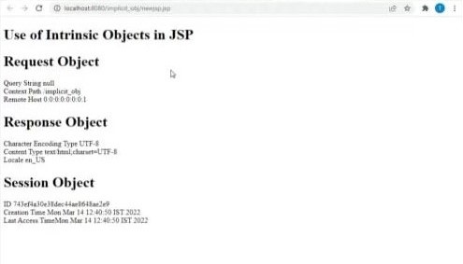

**Practical 4**

**Aim: Create Employees table in EMP database. Perform select, insert, update, and delete operations on Employee table using JSP.**

**Program Code:**

steps:

Create LoginDB

create table user(

username varchar(20) ,

password varchar(20),

email varchar(20),

country varchar(20));

html code:

<!DOCTYPE html>

<!--

To change this license header, choose License Headers in Project Properties.

To change this template file, choose Tools | Templates

and open the template in the editor.

-->

<html>

<head>

<title>TODO supply a title</title>

<meta charset="UTF-8">

<meta name="viewport" content="width=device-width, initial-scale=1.0">

</head>

<body>

<form action="RegisterServlet" method="get">

<H1>Welcome to Registration page</H1>

Enter User Name

<input type="text" name="txtUid"><br>

Enter Password

<input type="password" name="txtPass"><br>

Enter Email

<input type="text" name="txtEmail" ><br>

Enter Country

<input type="text" name="txtCon" ><br>

<input type="reset" >

<input type="submit" value="REGISTER" >

</form>

</body>

</html>

java servlet code:

/*

* To change this license header, choose License Headers in Project Properties.

* To change this template file, choose Tools | Templates

* and open the template in the editor.

*/

package test1;

import java.io.IOException;

import java.io.PrintWriter;

import static java.lang.System.out;

import javax.servlet.ServletException;

import javax.servlet.http.HttpServlet;

import javax.servlet.http.HttpServletRequest;

import javax.servlet.http.HttpServletResponse;

import java.sql.*;

/**

*

* @author user

*/

public class RegisterServlet extends HttpServlet {

/**

* Processes requests for both HTTP <code>GET</code> and <code>POST</code>

* methods.

*

* @param request servlet request

* @param response servlet response

* @throws ServletException if a servlet-specific error occurs

* @throws IOException if an I/O error occurs

*/

@Override

protected void doGet(HttpServletRequest request, HttpServletResponse response)

throws ServletException, IOException {

String id = request.getParameter("txtUid");

String ps = request.getParameter("txtPass");

String em = request.getParameter("txtEmail");

String co = request.getParameter("txtCon");

response.setContentType("text/html;charset=UTF-8");

try (PrintWriter out = response.getWriter()) {

Class.forName("com.mysql.jdbc.Driver");

Connection con =DriverManager.getConnection("jdbc:mysql://localhost:3306/logindb","root","root123");

PreparedStatement pst = con.prepareStatement("insert into user values(?,?,?,?)");

pst.setString(1,id);

pst.setString(2,ps);

pst.setString(3,em);

pst.setString(4,co);

int row = pst.executeUpdate();

out.println("<h1>"+row+ " Inserted Succesfullyyyyy");

}

catch(Exception e){

out.println(e);

/* TODO output your page here. You may use following sample code. */

out.println("<!DOCTYPE html>");

out.println("<html>");

out.println("<head>");

out.println("<title>Servlet RegisterServlet</title>");

out.println("</head>");

out.println("<body>");

out.println("<h1>Servlet RegisterServlet at " + request.getContextPath() + "</h1>");

out.println("</body>");

out.println("</html>");

}

}

}

**Output:**

